ASSIGNMENT#1
PROGRAMMING FUNDAMENTALS CT-175 ENGR. ASMA KHAN

SOFTWARE ENGINEERING SECTION A SE

Assignment No:1
Programming Fundamentals
FESE- Software Engineering Department

CLO-2(C3) Due Date:27th Sep,24
Apply the devised solutions into computer programs and test the programs on a computer.

It should be clear that your assignment will not get any credit if:
- The assignment is submitted after due date.
- The assignment is submitted via email.
- The assignment is copied from Internet or from any other student.

Q.1 Write a python program following any Sequence structure to generate this output.
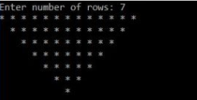

PROGRAM

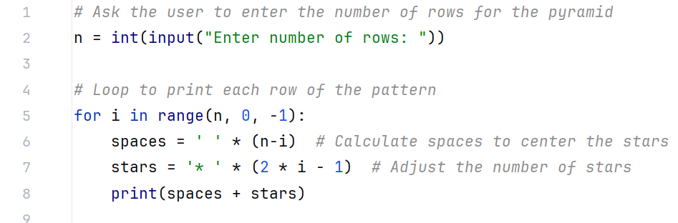

OUTPUT
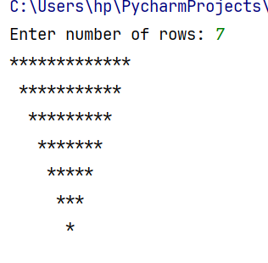
Q2 By using For loop in python program, generate the following series.
- 11 16 21 26 31 36 41

PROGRAM

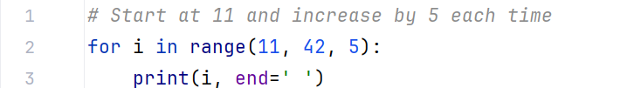

OUTPUT

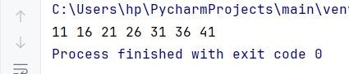

- 3 8 13 18 23 28 33

PROGRAM

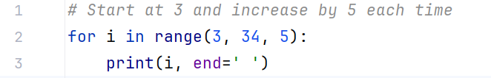

OUTPUT
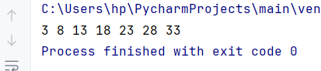

- 20 20 17 17 14 14 11

PROGRAM

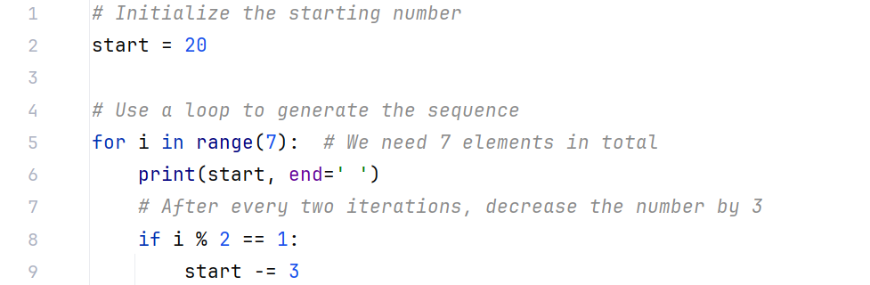

OUTPUT

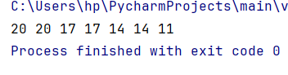

Q.3 Write a Python program to construct the following pattern, using a nested for loop

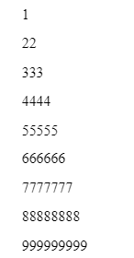

PROGRAM
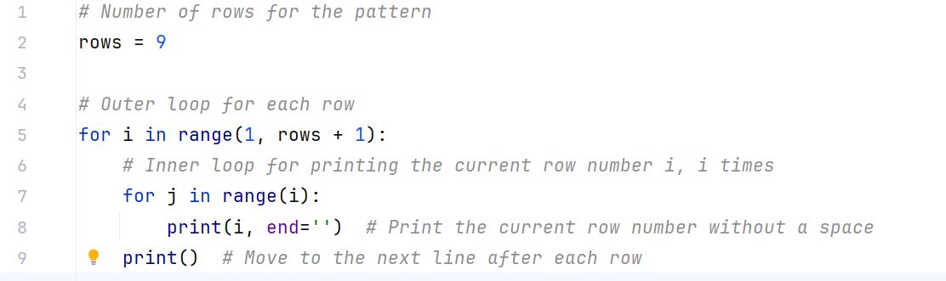
OUTPUT
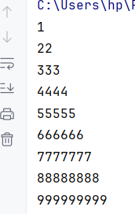

Q.4 Write a Python program that prompts for amount in rupees and show how many 1000’s, 500’s, 100’s, 50’s, 10’s, 5’s, 2’s and 1’s in it.

Sample run:
Enter amount in rupees: 5788
1000’s in the given amount is: 5
500’s in the given amount is: 1
100’s in the given amount is: 2
50’s in the given amount is: 1
10’s in the given amount is: 3
5’s in the given amount is: 1
2’s in the given amount is: 2
1’s in the given amount is: 1
PROGRAM
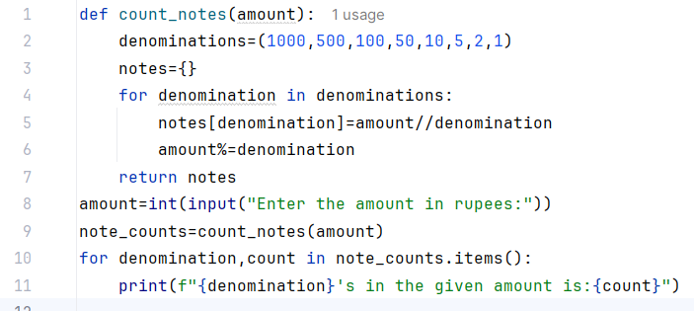
OUTPUT
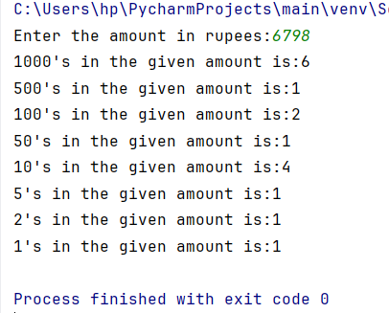
Q.5 Write a python program to perform the following conditional actions:
Given an integer,
- If is odd, print Karachi
- If is even and in the inclusive range of 2 to 5 , print Lahore
- If is even and in the inclusive range of 6 to 20 , print Islamabad
- If is even and greater than 20 , print Pakistan

PROGRAM
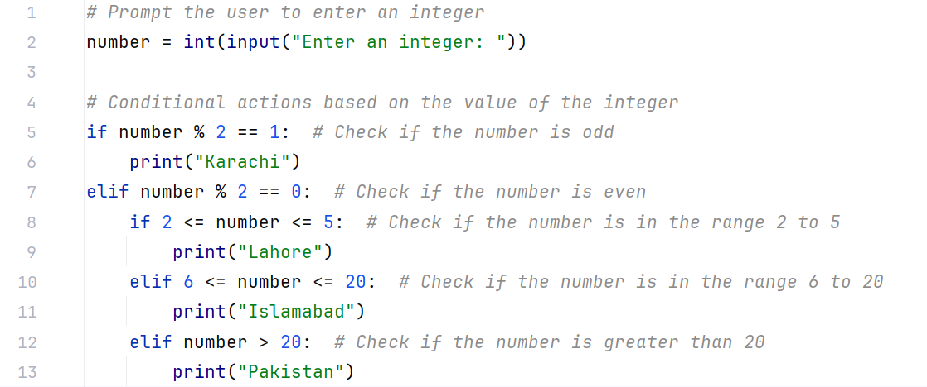

OUTPUT
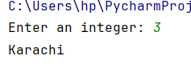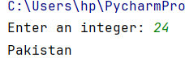
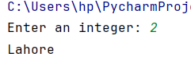
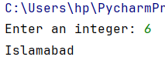

Q.6 Write a python program that takes age as an input and check If age is greater than or equal to 18, it checks the second condition for checking if one has license or not, If has_license is True, the person can drive, otherwise he can't.

PROGRAM
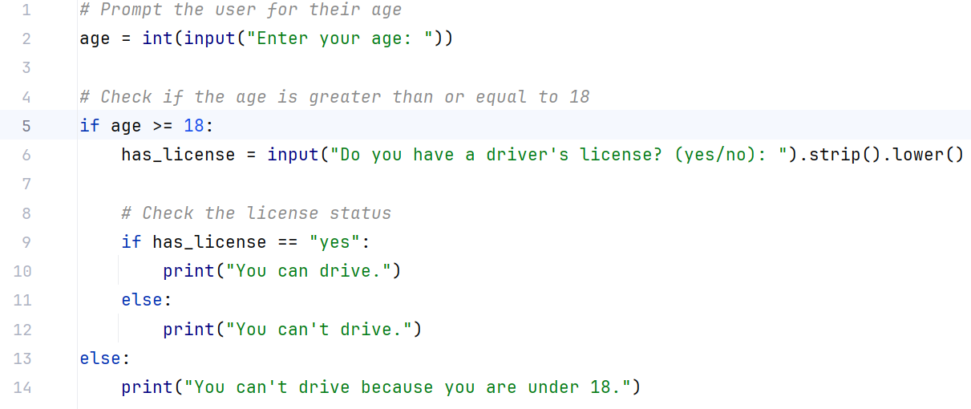
OUTPUT
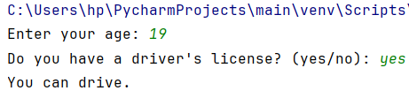
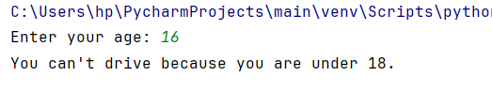
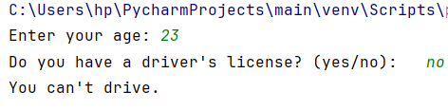

Q.7 Given a list of numbers holding numbers = [5, 10, -3, 7, -2, 9, -8, 4,-11]
- Print some message showing Skips processing negative numbers.
- terminates the loop when a number greater than 10 is encountered.
- Print ,All non-negative numbers less than or equal to 10 are processed.
PROGRAM
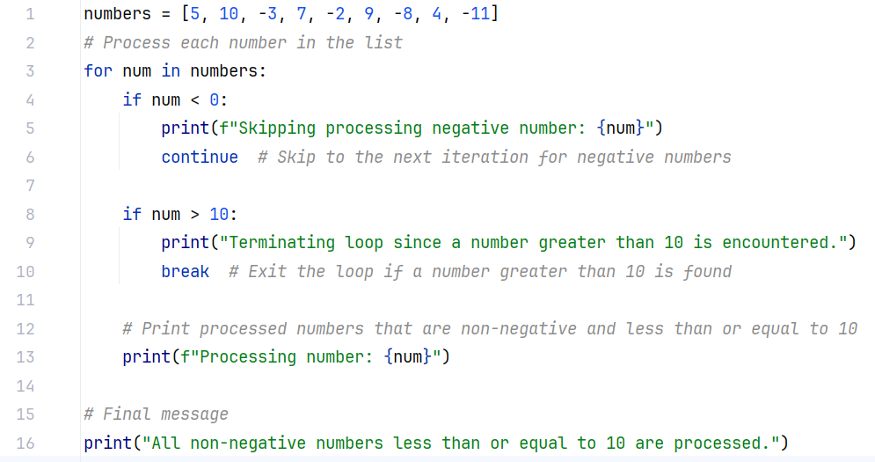
OUTPUT
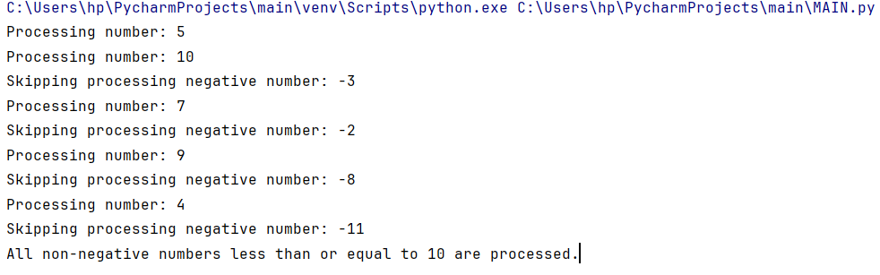

Q.8 Write a python program consisting of following conditions
• The loop allows the user to withdraw money until the balance becomes 0 or the number of attempts reaches the withdrawal limit.
• If the user tries to withdraw more than the available balance, it prints a message and skips the iteration (continue).
• If the balance reaches zero, the loop ends(break)

PROGRAM
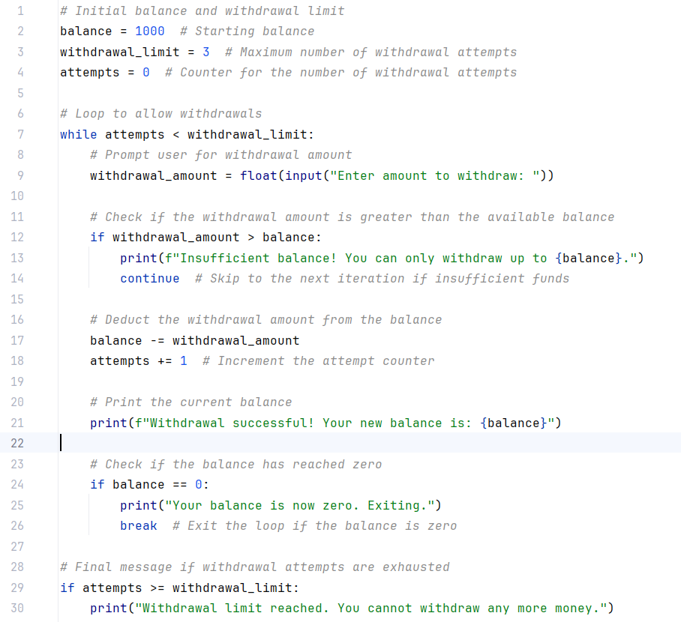
OUTPUT

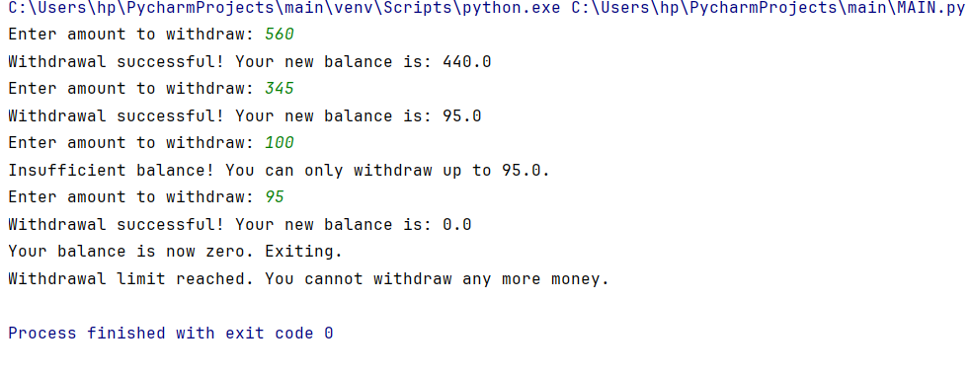

rows = int(input("Enter the number of rows for the pyramid: "))
# Top half (increasing stars)
for i in range(1, rows + 1):
print(str(i) * i)

